Andrew Rutherford

CSCI 3104

CPU: 2.8 GHz Intel Core i7

Ram: 16 GB 1600 MHz DDR3

OSX Yosemite

Homework #8

On my honor, as a University of Colorado at Boulder student, I have neither given nor received any unauthorized help.

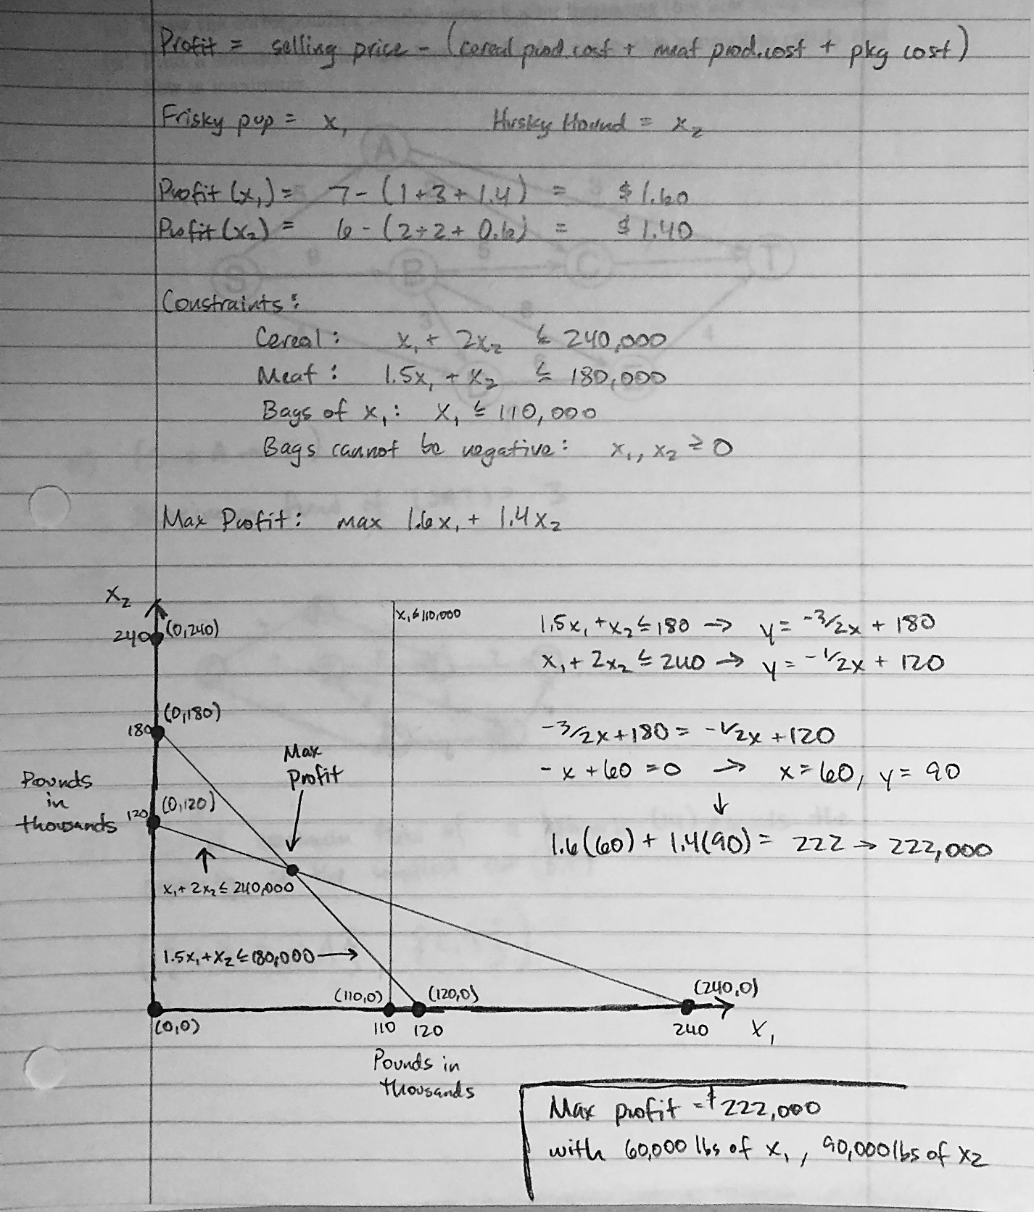

2.

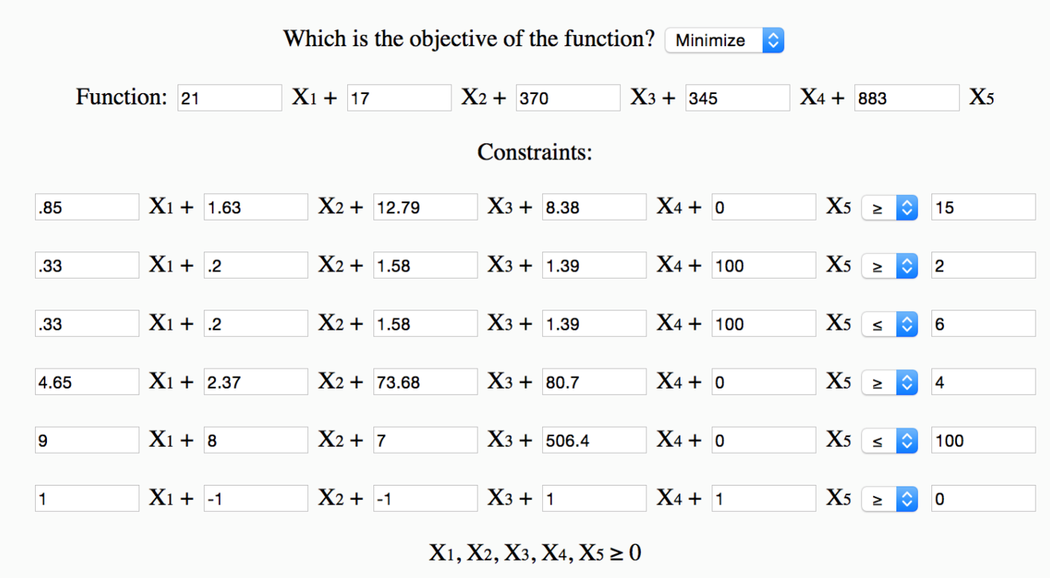

Variables:

X1 = tomato, X2 = lettuce, X3 = spinach, X4 = carrot, X5 = oil

Optimal Solution:

5.8845 portions of tomato

5.8481 portions of lettuce

.03642 portions of spinach

0 portions of carrots

0 portions of oil.

Constraints:

Protein at least 15g

Fats between 2g and 6g

Carbs at least 4g

Sodium at most 100g

At most 50% greens by mass

Source: <http://www.phpsimplex.com/simplex>

